**LAB # 03**

**XOR & XNOR GATE**

**Objective**

To study the behavior of the XOR gate & XNOR gate.

**Requirement**

* 7486 IC (XOR gate)
* 7402 IC (NOR gate)
* LED
* Multisim
* 5 Volt DC Power Supply

**Theory**

**XOR Gate**

In two input XOR Gate:

When both inputs are same either both are 1 or 0, the output is 0

When both inputs are different, the output is 1

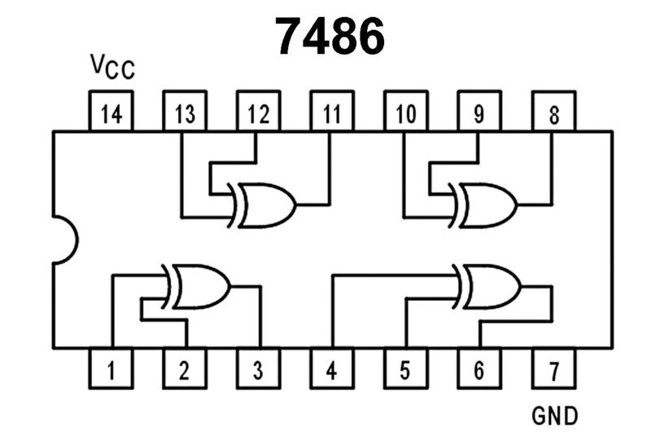

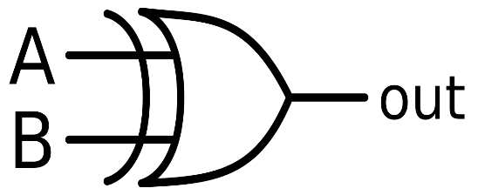



7486 XOR Gate IC

Logic symbol of XOR

**XNOR Gate**

In two input XNOR Gate:

When both inputs are same either both are 1 or 0, the output is 1

When both inputs are different, the output is 0

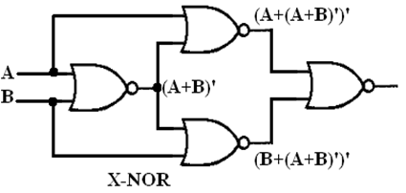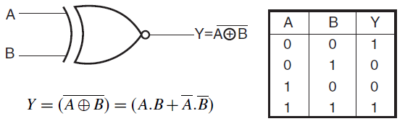

Logic symbol of XNOR

**Procedure**

Design the circuits with the help of layout provided and verify the operation of given gates. Pin no 7 and pin no 14 of IC is ground and VCC respectively. Apply different inputs and observe the outputs and then complete the truth tables.

**Truth Table**

1. **XOR Gate**

|  |  |  |
| --- | --- | --- |
| A | B | Y= |
| 0 | 0 |  |
| 0 | 1 |  |
| 1 | 0 |  |
| 1 | 1 |  |

1. **XNOR Gate**

|  |  |  |
| --- | --- | --- |
| A | B | Y= |
| 0 | 0 |  |
| 0 | 1 |  |
| 1 | 0 |  |
| 1 | 1 |  |

**Questions**

1. Consider a chemical dispensing system that has two chemicals in it. The system dispenses one chemical at a time. There are two push buttons i.e. PB1 for chemical A, PB2 for chemical B and a single output valve. In case when both push buttons are pressed simultaneously no chemical will be dispensed from the output valve. Draw a circuit for the above condition and show the truth table.

2. Draw **XOR** gate using NOR gate.